Detect.Defend.Deliver Justice.

Bahria University,Lahore.

Crime Management System Documentation Report

May 11,2026.



Submitted By: Abiha Musaddaq and Hamd Amjad | Enrollment Numbers: 08 and 26

Course: OOP(object Oriented Programming

Ms.Zoobiab Fatima

📄 CRIME MANAGEMENT SYSTEM
Detect.Defend.Deliver Justice. 1
CRIME MANAGEMENT SYSTEM 2
1) Project Overview 2
Purpose of the System 3
2) System Structure / Class Design 3
Class Structure 3
CrimeRecord Class (Core Entity) 3
Officer Class (Composition) 3
Evidence Class (Composition) 4
CrimeSystem Class (System Controller) 4
Relationship Diagram (Text-Based Class Structure) 4
3) Object-Oriented Programming Concepts Used 4
Encapsulation 5
Example: 5
Abstraction 5
Example: 5
Inheritance (Conceptual Use) 5
Polymorphism (Conceptual + Design Level) 5
Composition (Strongly Used) 5
CrimeRecord "has-a": 6
File Handling 6
Features: 6
Data Structures 6
Menu-Driven Interface 6
4) Future Enhancements (Add this to your report) 6
Graphical User Interface (GUI) 6
Advanced Analytics Dashboard 7
Mobile Application Version 7
5) Conclusion 7
✔ Key Achievements: 7

1) Project Overview
The Crime Management System is a console-based C++ application designed to manage and store crime-related records efficiently. It allows users (such as law enforcement officers or system administrators) to perform operations such as adding, viewing, searching, updating, and deleting crime cases.
Each crime case contains important information such as:
- Case ID
- Crime Type
- Criminal Name
- Age of Suspect
- Date of Crime
- Case Status (Open/Closed)
- Assigned Officer
- Evidence details
The system also includes a statistics dashboard that displays:
- Total number of cases
- Number of open cases
- Number of closed cases

Purpose of the System
The main purpose of this project is to demonstrate the use of Object-Oriented Programming (OOP) concepts in solving a real-world problem while maintaining data persistence using file handling.

2) System Structure / Class Design
The system is designed using multiple interacting classes to ensure modularity and reusability.

Class Structure

1. CrimeRecord Class (Core Entity)
This is the main class that stores all information about a crime case.
Attributes:
- caseID
- crimeType
- criminalName
- age
- date
- status
- Officer object
- Evidence object
Functions:
- input() → Takes user input
- display() → Shows record details
- toFile() → Converts data into file format
- setStatus() → Updates case status

2. Officer Class (Composition)
Represents the police officer assigned to a case.
Attributes:
- name
- badgeID
Functions:
- input() → Takes officer details
- toString() → Returns formatted officer info

3. Evidence Class (Composition)
Stores evidence related to a crime case.
Attributes:
- List of evidence items (vector<string>)
Functions:
- input() → Takes multiple evidence entries
- toString() → Converts evidence list to string

4. CrimeSystem Class (System Controller)
This class manages all operations and acts as the system manager.
Responsibilities:
- Store all crime records (vector)
- File handling (load/save)
- Add, update, delete, search operations
- Display statistics dashboard
- Provide user menu interface

Relationship Diagram
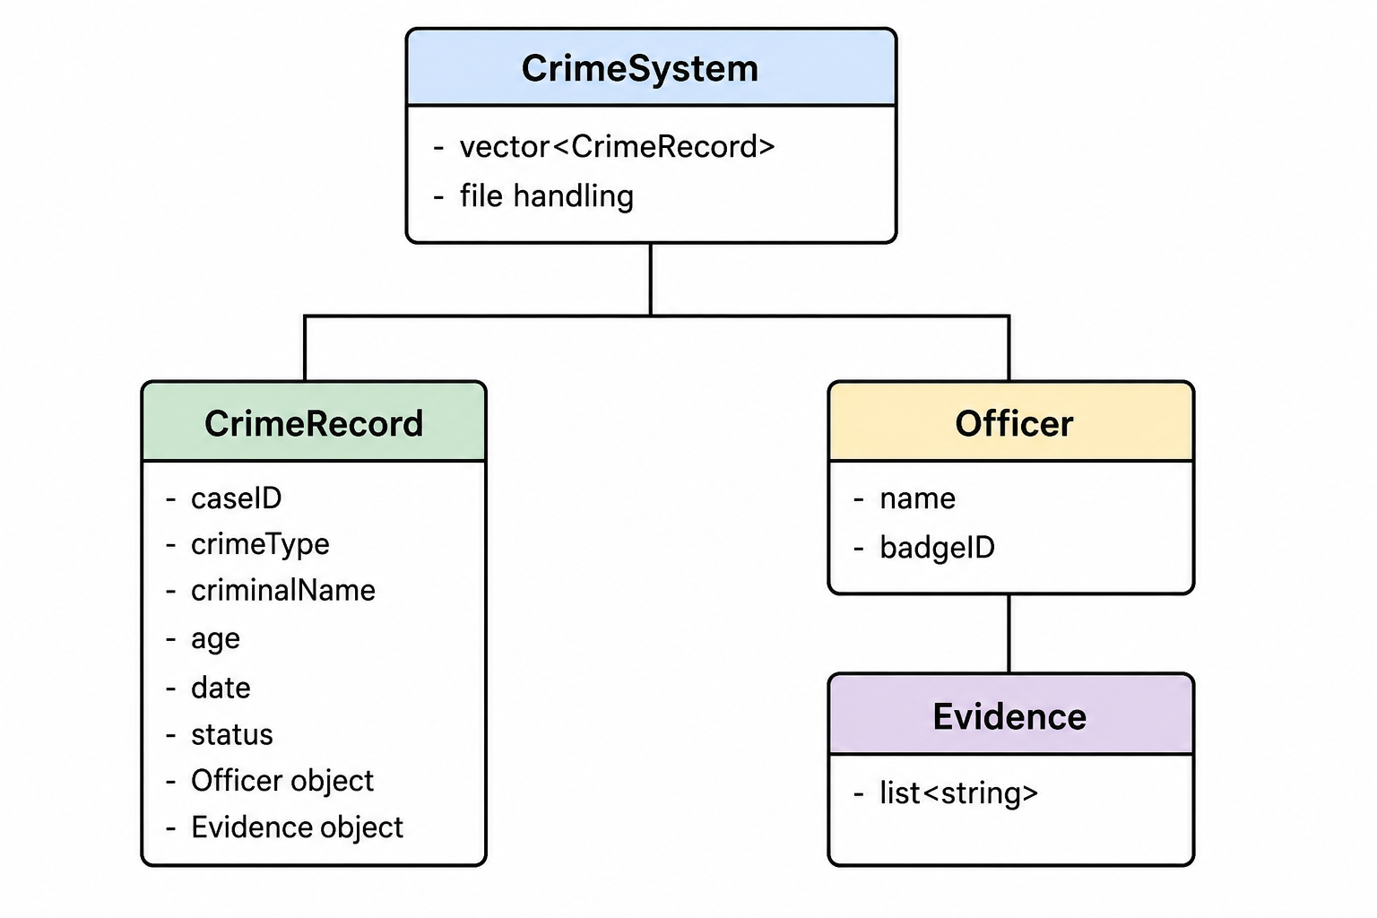

3) Object-Oriented Programming Concepts Used
This project strongly demonstrates the following OOP principles:

Encapsulation
Encapsulation is achieved by keeping data members private inside classes and controlling access through member functions.

Example:
- Crime details are stored as private variables.
- Access is provided through functions like input(), display(), and setStatus().
✔ This ensures data security and prevents direct modification.

Abstraction
Abstraction hides internal implementation details and exposes only necessary functionalities.

Example:
- Users only interact with menu options like Add, Delete, Update.
- Internal file handling and parsing logic is hidden inside CrimeSystem.
✔ This simplifies user interaction.

Inheritance (Conceptual Use)
Although the final version focuses more on composition, earlier structure ideas support inheritance-based design (CrimeRecord can be extended in larger systems for specialized cases like cybercrime, theft, etc.).
✔ This shows scalability of the system.

Polymorphism (Conceptual + Design Level)
Polymorphism is represented through function behavior consistency:
- input() behaves differently in different classes (CrimeRecord, Officer, Evidence).
- Same function name, different behavior.
✔ This supports extensibility and modular design.

Composition (Strongly Used)
This is the most important concept used in the project.

CrimeRecord "has-a":
- Officer
- Evidence
✔ This represents real-world relationships:
A crime case contains officers and evidence.

File Handling
File handling is used for permanent data storage.

Features:
- Save records to file (crimes.txt)
- Load records when program starts
- Maintain persistent data even after program exit
✔ This simulates real database-like behavior.

Data Structures
- vector<CrimeRecord> is used to store multiple records dynamically.
✔ Allows flexible memory management.

Menu-Driven Interface
The system uses a loop-based menu system that allows users to interact easily with the application.
Features:
- Add record
- View records
- Search
- Delete
- Update
- View statistics
- Output Screenshots
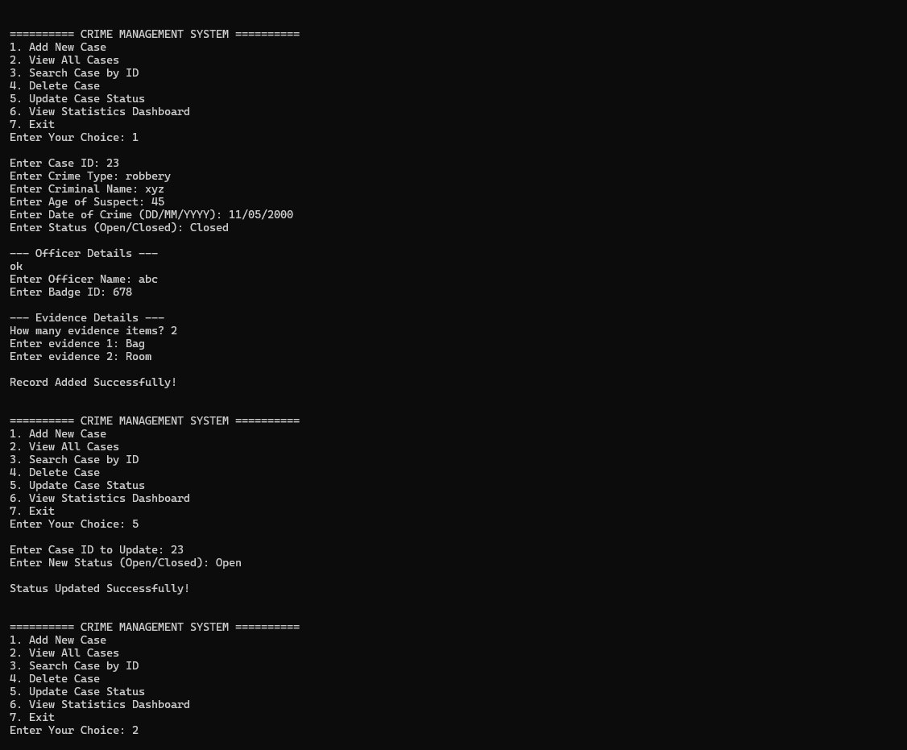

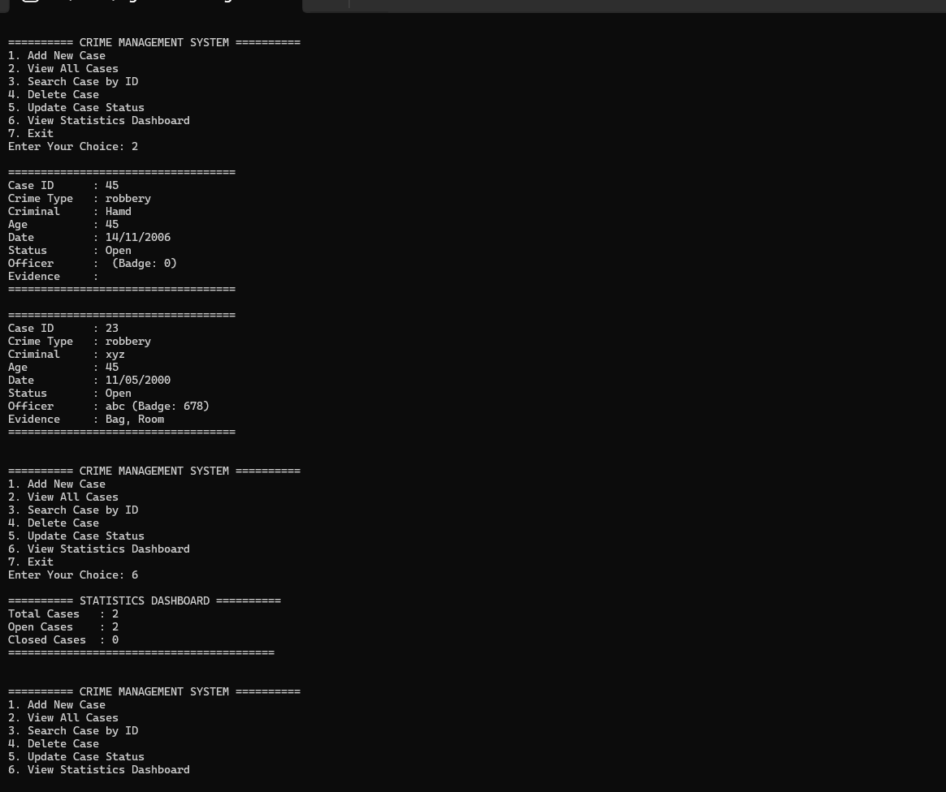

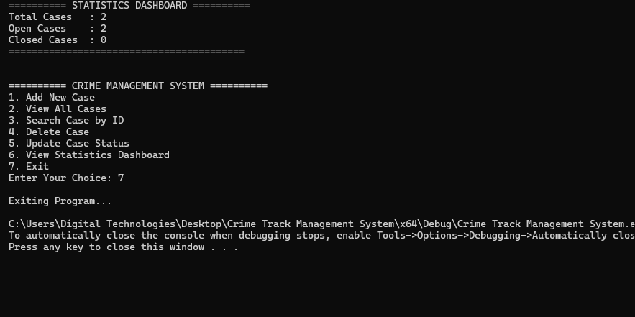

5) Future Enhancements
The current Crime Management System is a functional console-based application. However, it can be further improved and expanded in the future with the following features:

Graphical User Interface (GUI)
- Convert console system into a GUI application using SFML or Qt
- Add buttons, forms, and dashboards
- Improve user experience and interaction

Advanced Analytics Dashboard
- Graphical representation of:
  - Crime trends over time
  - Most common crime types
  - Monthly statistics
- Pie charts / bar graphs for better visualization

Mobile Application Version
- Android/iOS version of the system
- Officers can update cases on the go

6) Conclusion
The Crime Management System is an efficient simulation of a real-world law enforcement record system. It demonstrates strong usage of Object-Oriented Programming principles along with file handling and structured system design.

✔ Key Achievements:
- Modular class-based design
- Real-world data modeling
- Persistent storage system
- Functional dashboard
- Easy-to-use interface
Github Link:

